**Experiment 10: Computational Chemistry: Geometry**

**optimization using Avogadro software**

**Name:** Vidhi Shah

**Reg. No.:** 21BCE1297

**Slot:** L11-L12

**Date:** 21/12/21

1. Comparison and modelling of **water (H2O)** **dimer** and **H2S** **dimer** to investigate the influence of ***intermolecular* hydrogen bonding**.
2. 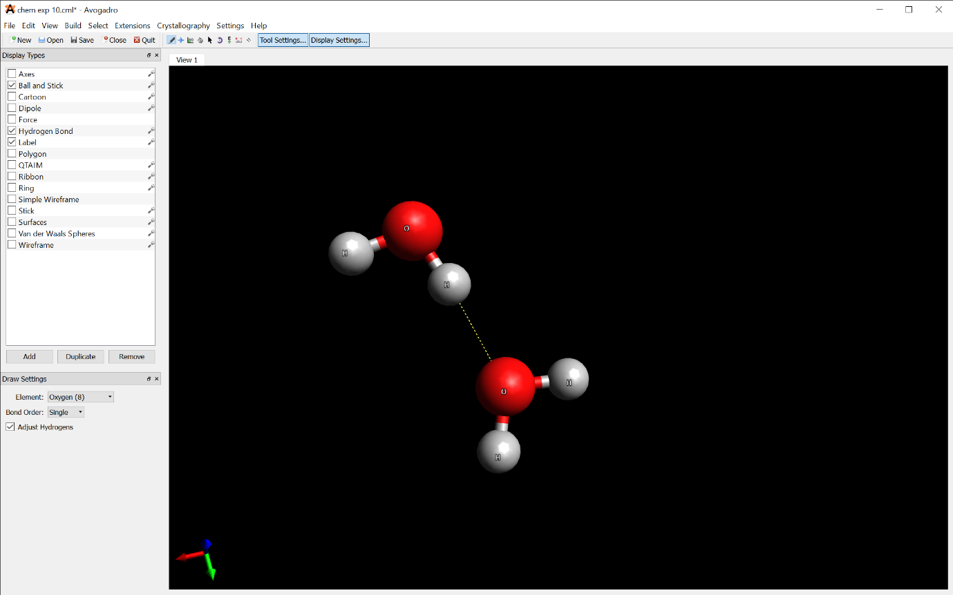**H2O**

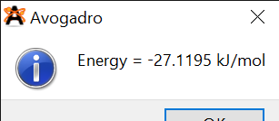

1. 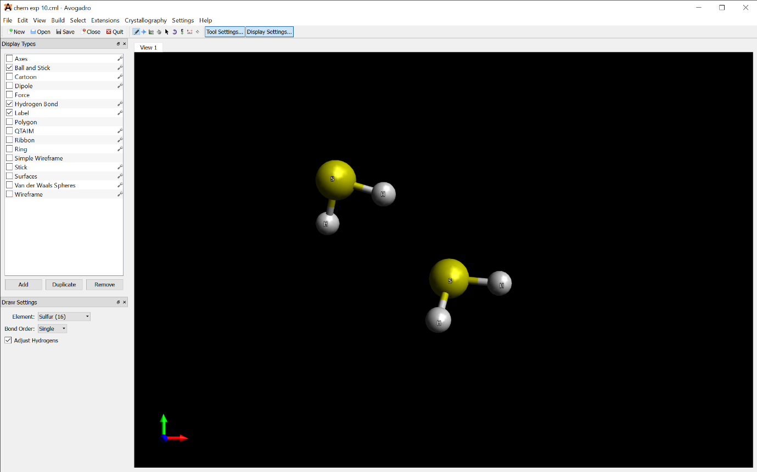**H2S**

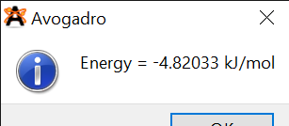

1. 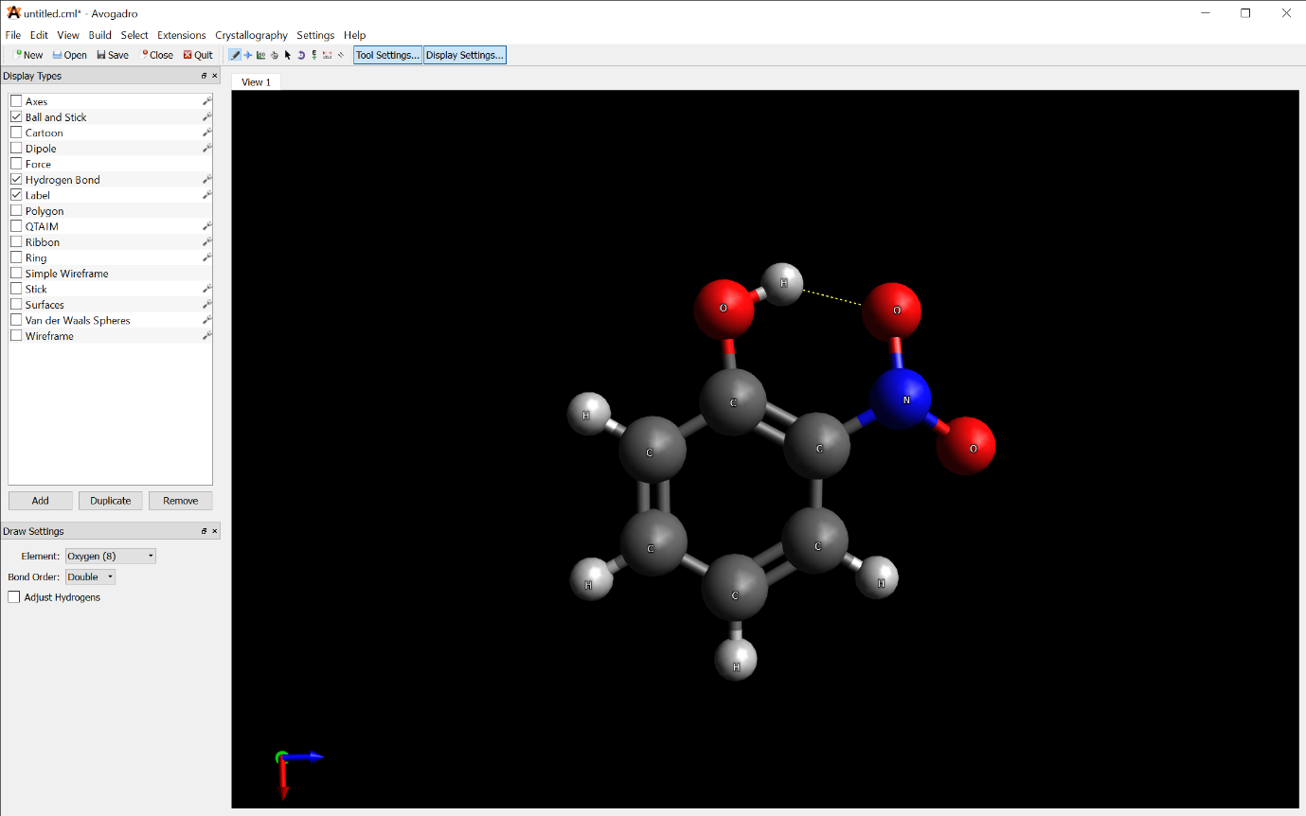Modelling of **2-nitrophenol** to study the influence of ***intramolecular* hydrogen bonding**.

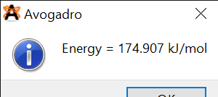

**Results:**

1. Visualize the geometry of H2O and H2S dimers.
2. The energy of **H2O dimer** = -**27.1195 kJ/mol**

**H2S dimer** = -**4.82033 kJ/mol**

1. Visualize the geometry of 2-nitrophenol.
2. The energy of **2-nitrophenol** = 1**74.907 kJ/mol**